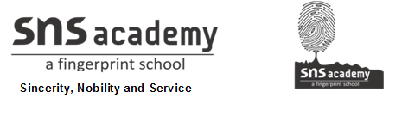

SOCIAL STUDIES

WORKSHEET -1

- KNOW YOUR PLANET

NAME: GRADE: V

DATE:

I.CHOOSE THE CORRECT ANSWER

1. Africa is --------------

a. An ocean b. A country c. A continent

2. What does the Latin word mappo mean?

a. Paper b.napkin c.planet

3. Which of these is an ocean?

- the Brahmaputra b.Pacific c.South America

4. A Map which gives information on climate and rainfall of a region is called a ----------------------.

a..Political map b. climatic map c. population map

5. The Earth is shaped like ----------------.

a. A Rectangle b. A Triangle c .a Sphere

II.WHO AM I?

1.I am used to finding directions. --------------------------

2.I represent a part of the Earth on a flat surface. --------------------------

3.I help people to understand the colour scheme and symbols on a map.

-----------------------------.

4.I am an unique planet. --------------------------.

III.MATCH THE FOLLOWING

SECTION A | SECTION B
1. Ferdinand Magellan | A book of maps
2.Gerardus mercator | countries and capitals
3.Highlands | a portuguese Explorer
4.Political map | intermediate direction
5.Atlas | a Flemish map maker
6.North East | shades of Brown

IV.COMPLETE THE FOLLOWING SENTENCES
1. A map is more convenient to use than a globe because

2. Our Earth is a unique planet because

